**Working with a Selenium Test Case – Lab_01_SPEQM**

1. Open the Chrome web browser
2. Open Selenium IDE by clicking on the Selenium icon

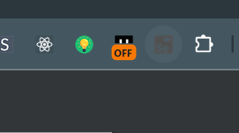

1. Click on “Record a new test in a new project”

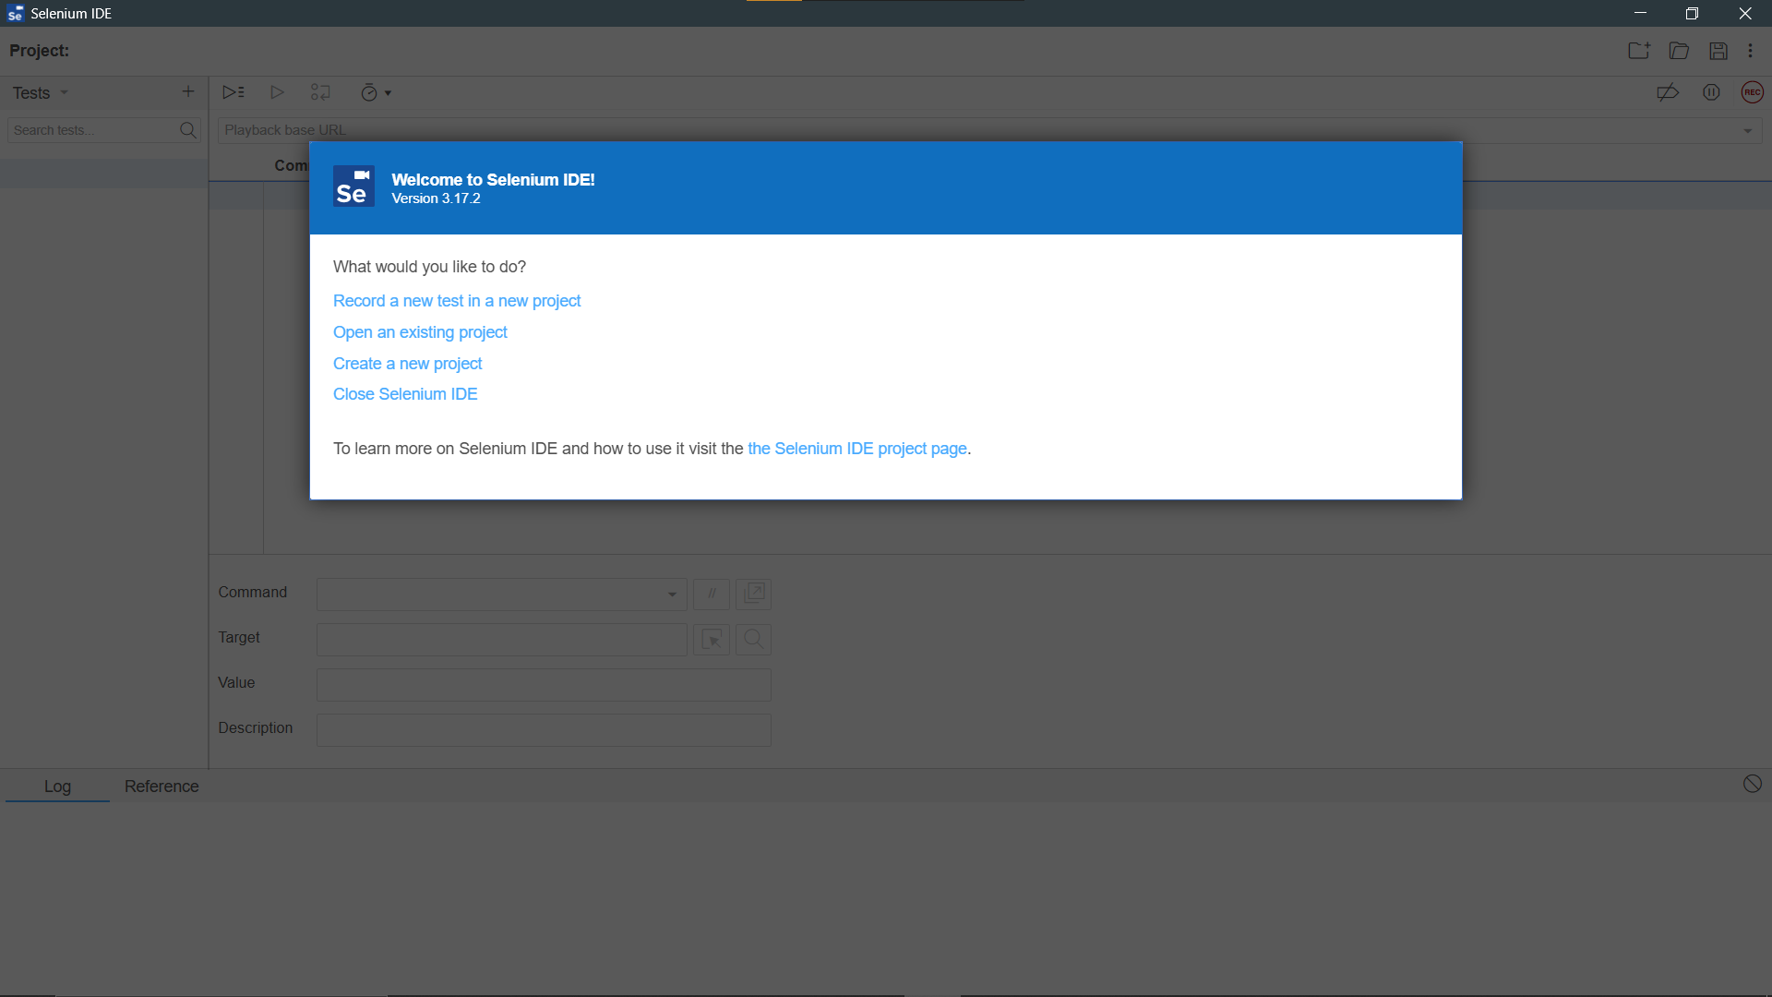

1. Give a name for the project. Then click “OK”

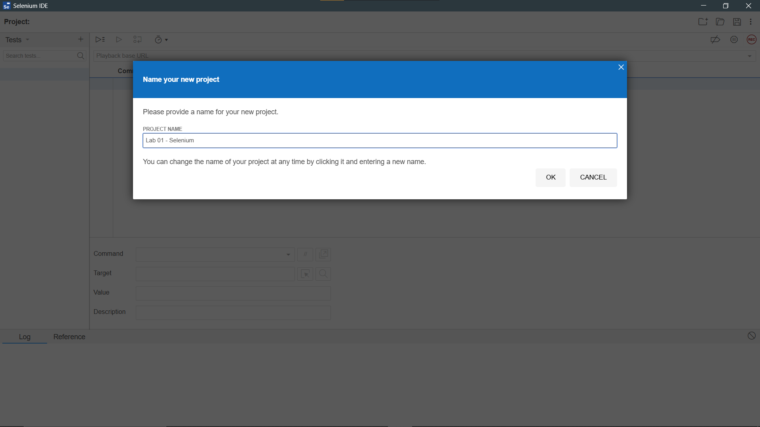

1. Give names for the each Test Cases. Then click “OK”

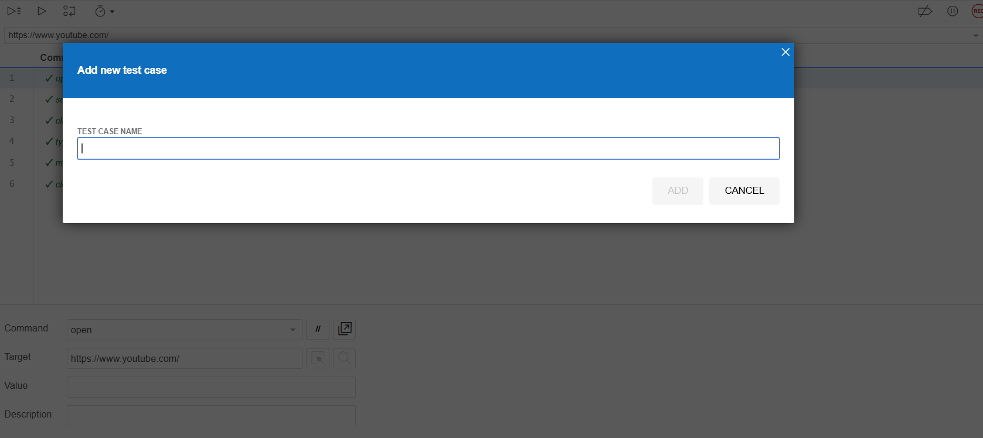

1. Give the web address for each test cases and Click on “Start Recording”.

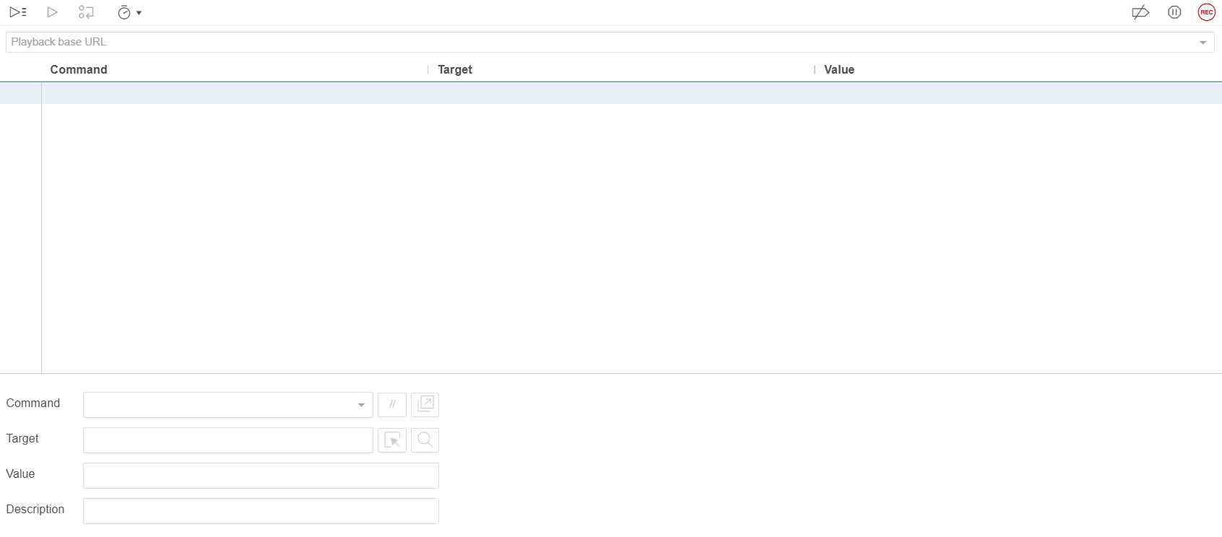

**Now the web address will be opened, and recording will get started. You can navigate through different tabs of the webpage.**

1. Click on “Stop Recording” button

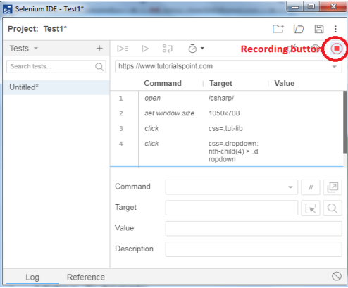

1. Based on your choice you can either execute one test case at a time or all the test cases together. Here the 5 test cases that have been executed.

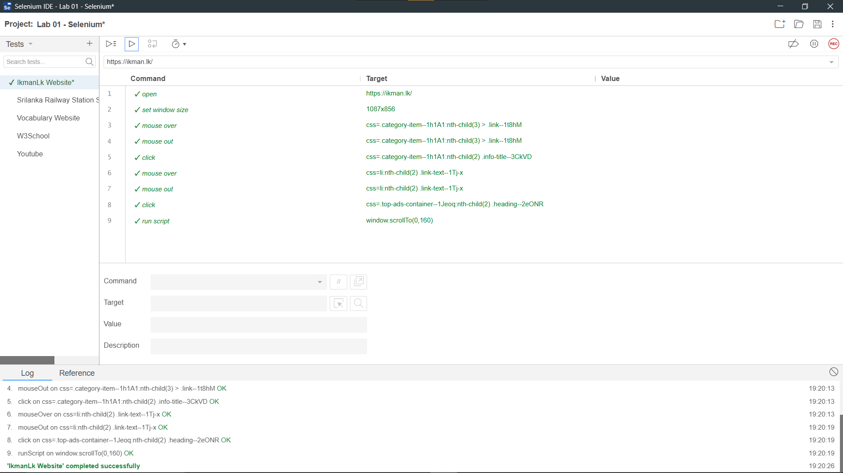

* **This is a test case which has been done to a online marketplace which is called ikman.lk**

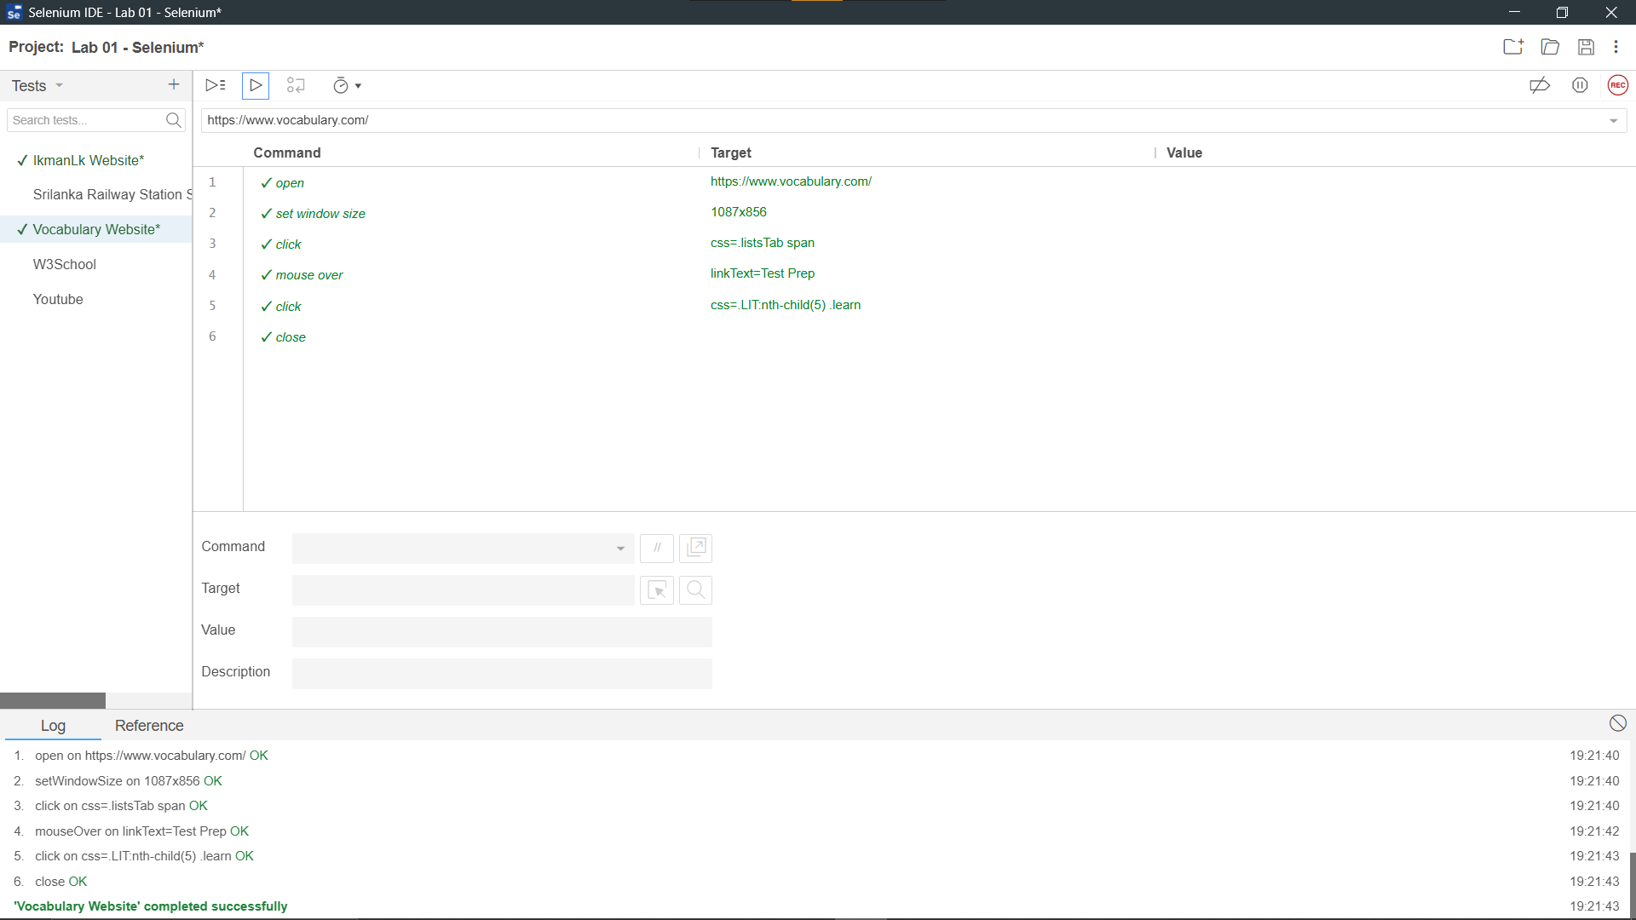

* **This is a test case which has been done to a online Vocabulary site which is called Vocabulary**

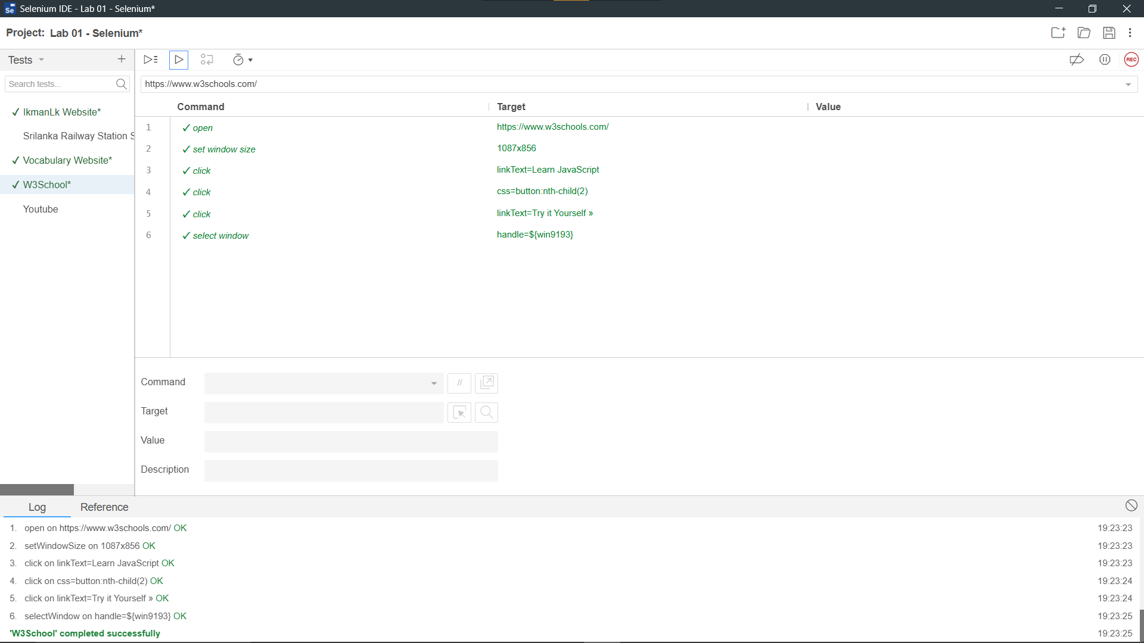

* **This is a test case which has been done to a online learning site which is called W3school**

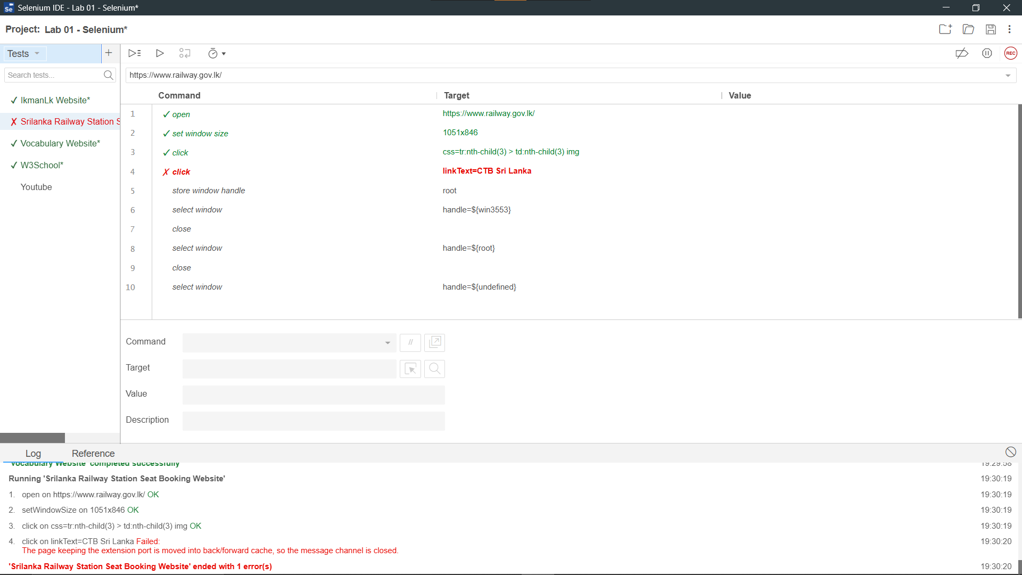

* **This test case was conducted on a Sri Lankan online railway website, and in some instances, it failed. The issue occurred because the page retained the extension port when navigating through the back/forward cache.**

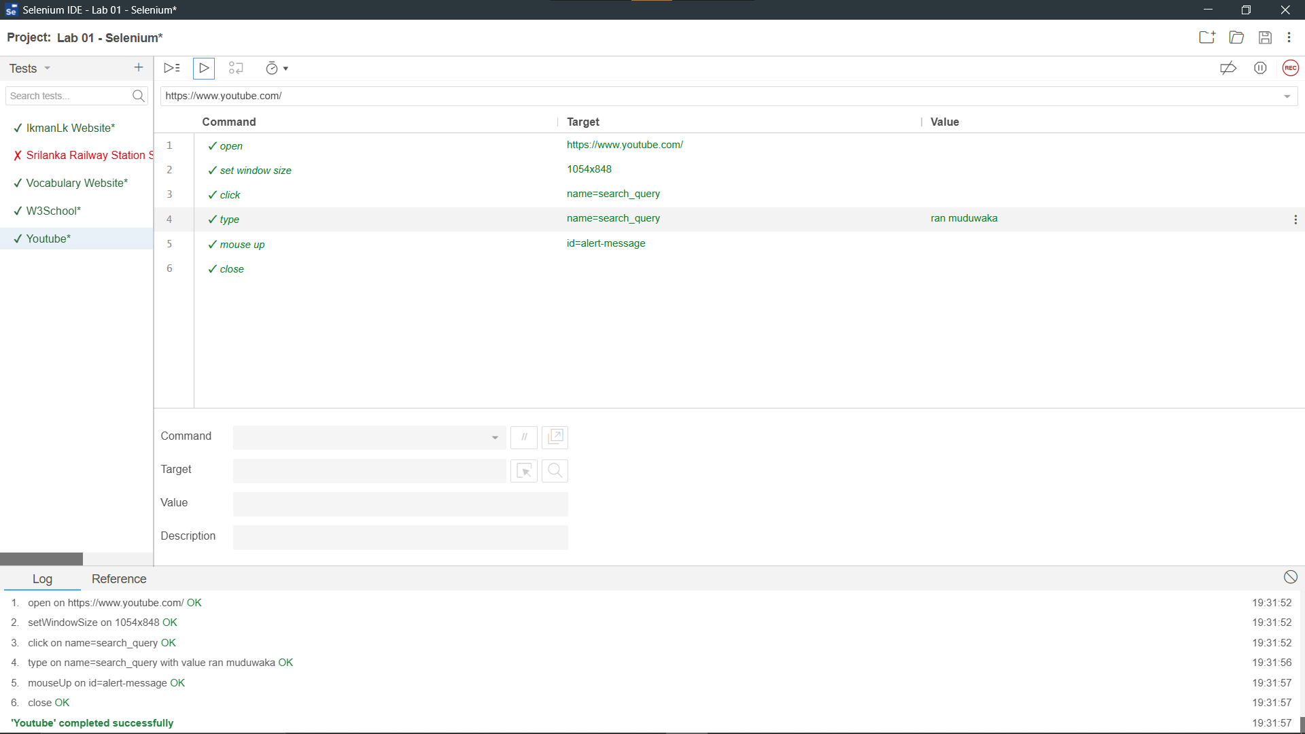

* **This is a test case conducted on an online media site for YouTube**.